Sanderson Field R/C Flyers New Pilot
Trainer Aircraft Reference Guide
This sheet is to help the new pilot pick a proper aircraft and the correct equipment to go with it, to make the learning experience as fun and easy as possible.

Aircraft:
Kits:
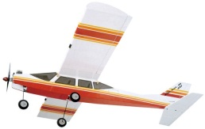 Midwest Aerostar .40 Kit – You can find on Ebay or at Midwest online. Kits will run around $100.

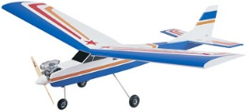 Great Planes PT-40 Mk.II Kit – You can find Tower Hobbies online or your local hobby shop. Kits will run around $90.

ARFs:
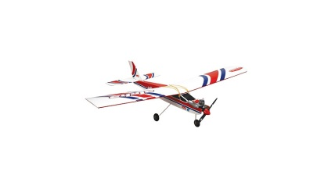Hangar 9 Alpha .40 ARTF – You can find from Horizon Hobby or your local hobby shop for around $140.

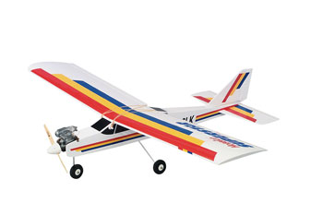 Hobbico Superstar .40 ARF – You can find from Tower Hobbies or your local hobby shop for around $125.

Ready To Fly:
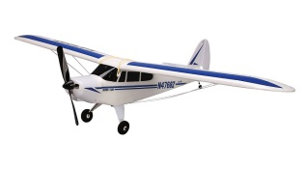 Hobbyzone Supercub DSM RTF – You can find from Horizon Hobbies or your local hobby shop for around $200.
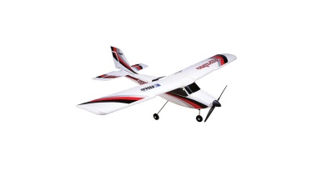 EFlite Apprentice 15e RTF – You can find from Horizon Hobbies or your local hobby shop for around $300.

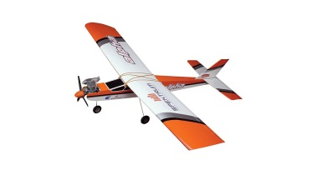 Hangar 9 Alpha .40 Trainer RTF – You can find from Horizon Hobbies or your local hobby shop for around $340.

Aircraft Engines:
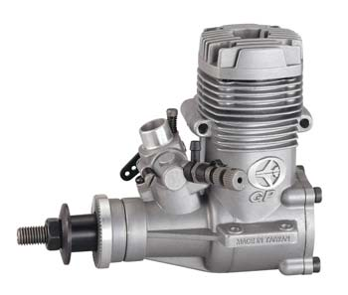 Thunder Tiger GP .42 – You can find from Tower Hobbies or your local hobby shop for around $90.
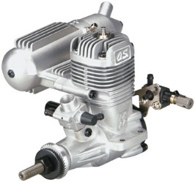 OS .46 LA – You can find from Tower Hobbies or your local hobby shop for around $90.

Aircraft Radios:
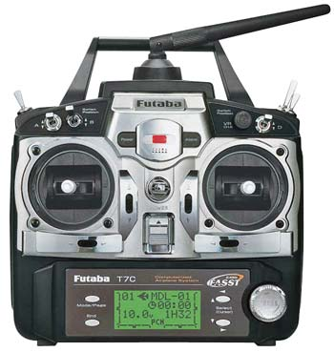 Futaba 7C 2.4GHz FASST Radio System – You can find from Tower Hobbies or your local hobby shop for around $280. Futaba is currently running a promotion that when you buy a new 7C system; you get an extra Futaba 2.4GHz receiver for free! That’s an extra $90 savings!

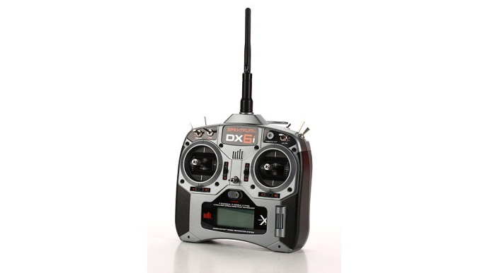 Spectrum DX6i DSMX 6 Channel Full Range without Servo – You can find from Horizon Hobby or your local hobby shop for around $210.

Aircraft Servos:
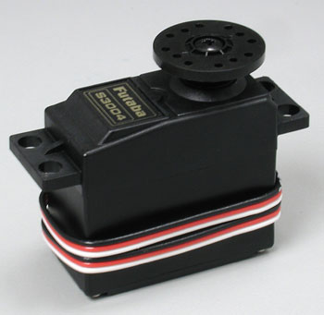 Futaba 3004 Standard Size Ball Bearing Servo – You can find from Tower Hobbies or your local hobby shop for around $14.

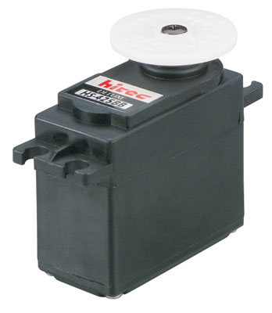 HiTec HS425 Standard Size Ball Bearing Servo – You can find from Tower Hobbies or your local hobby shop for around $13.

Radio Batteries:
The Transmitters you buy from the Dealers or the Hobby Shop will come with batteries. These batteries are very small in capacity, and will need to be charged often during your flying day. Replace with these high capacity packs, and easily fly worry free all day!
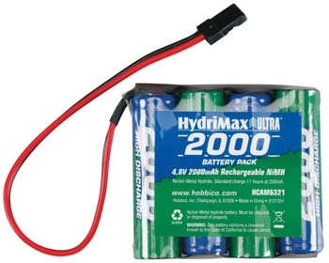 Hobbico Hydramax 4.8V 2000mAh NiMH Flat Receiver Pack – You can find from Tower Hobbies or your local hobby shop for around $21.

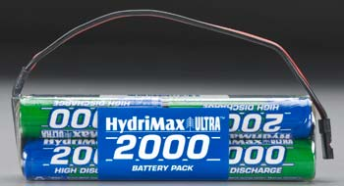 Hobbico Hydramax 9.6V 2000mAh NiMH Flat or Square Transmitter Pack – You can find from Tower Hobbies or your local hobby shop for around $36.

Building Equipment:
All of the following Products should be found at your local Hobby Shop.
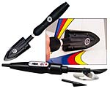21st Century Covering Irons Gift Pack - $50
This Package includes Sealing Iron and smaller Trim Sealing Iron

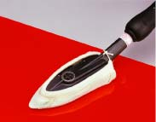 21st Century Covering Sock - $4

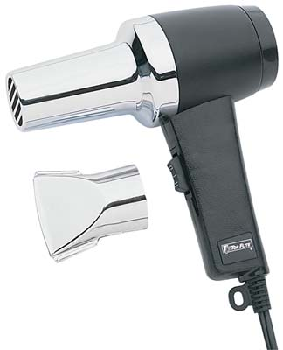 Top Flite Heat Gun - $20

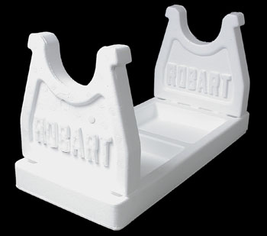 Robart 401 Super Stand - $14

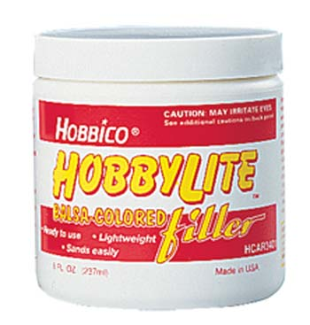 Hobbico Hobbylite Balsa-Colored Filler 8 oz - $5
Thin CA –
Thick CA –
5 minute epoxy –
30 minute epoxy –
Popsicle Sticks –
Mixing Cups –
Epoxy Brushes –
Micro Balloons –
Milled Glass –
Thread Locker –
Push Pins –
Vises –
Tool Box or Organizer –
Screw Drivers –
Alan Head Drivers –
Nut Drivers –
Open End Wrenches –
Needle Nose Pliers –
Pliers –
X-acto Knife –
X-acto Knife #11 Blades –
X-Acto Extra Fine Razor Saw Set Carded –
Sharpie –
Pencil –
Pencil Sharpener –
Assorted Wet and Dry Sandpaper –
Rubbing Alcohol –
Rubber Cement Thinner –
Acetone –
Paper Towels –

Field Equipment:
All of the following Products should be found at your local Hobby Shop.
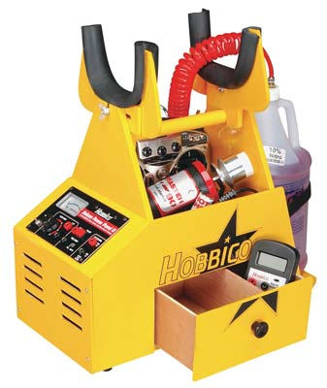 Hobbico Ultra-Tote Prebuilt ARH Yellow - $40
This box is pre-built and comes in Yellow, Red, or Blue. This Price is for box only.
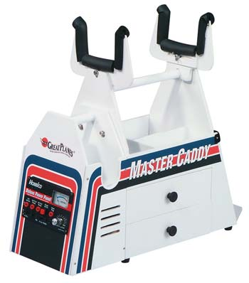 Great Plane Master Cady Prebuilt - $45
This box is pre-built and features a separate removable Starter Box for convenience. This Price is for box only.

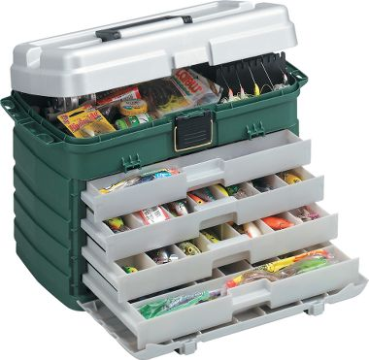 Portable tool container, and tackle boxes work great for this! Items can be found at any store that sells fishing equipment. Available in various sizes and prices.

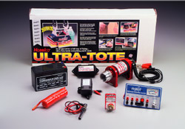 Hobbico Ultra-Tote Field Box Complete Combo - $130
This package includes everything you need for your flight box except tools. Power panel, starter, electric fueler, glow driver, and 12v Battery. Box comes unassembled and unpainted, but this process can easily be done in one day.

Starter –
Fuel Pump –
Glow - Driver –
Power Panel - If using a large field box
12v Battery - If using a large field box
Spare Glow Plugs –
Glow Plug Wrench –
Forceps –
Battery Tester –
Extra Props –
Spare Servos –

This should cover almost everything a person should need to get started in the wonderful world of remote control aviation! I know the list look long and some items can be quite expensive. Just remember, anytime you jump into a new hobby or activity, the entry costs can be a bit much. But I promise, the long term reward is well worth the early expense! If you have any questions about this list, or anything else please feel free to email me at Flyboy23e@aol.com!

Tom Strom Jr.

